Secondary Engagement at 12 and 24 Weeks: Window on Neuro-Cognitive Development

S. L. Gin, D. DeWald, D. A. Baldwin, J. Measelle, E. S. Anderson, S. L. Fisher, N. C. Moranville, D. D. Nunez-Silva, T. N. Elliot, H. Kroeun, S. Prak, & K. C. Whitfield

University of Oregon, Helen Keller International, Cambodian Health Ministry, & Mount Saint Vincent University

Joint attention interactions – also known as secondary engagement – are catalysts for learning (e.g., Bruner, 1983; Tomasello, 1999). Within such interactions, learners can anchor information caregivers offer – about language, emotions, object functions, and the like – to the object of joint focus. Given the power of secondary engagement for learning, and thus neuro-cognitive development, it is surprising that these interactions are rarely harnessed for clinical assessment of neuro-cognitive development. This study investigates the value of a new task – the Secondary Engagement Task (SET) – for assessing neuro-cognitive development. We report here on preliminary analyses aimed at basic validation of the SET.

The research was conducted as part of a double-blind, randomized, controlled trial in Cambodia examining possible benefits of maternal thiamine (vitamin B1) supplementation for breastfed infants’ neuro-cognitive development (Measelle, et al., 2021). The larger clinical trial involved 335 breastfeeding mother-infant pairs receiving thiamine supplementation from 2-24 weeks postpartum. Dyads participated in the SET when infants were both 12 and 24 weeks old. We report here on results for 99 dyads.

In the SET, caregivers were asked to establish and sustain their infant’s interest in a novel object over the course of five 30-second epochs; they were prompted to add and then subsequently remove cues to secondary engagement (e.g., line-of-regard, voice and gesture) as these epochs unfolded (Figure 1).

We rated infants’ secondary engagement behavior via a 1-6 Likert scale adapted from Bakeman and Adamson’s (1984) classic investigation into early joint engagement skills (e.g., 1 = no engagement with either object or mother; 3 = engagement with one or the other but not both; 6 = clear signs of conscious joint engagement with both mother and object). We predicted that secondary engagement ratings would a) display a quadratic pattern over the course of the SET as mothers first added and then removed cues to secondary engagement across epochs, and b) increase from 12- to 24-week timepoints.

Preliminary analyses confirmed both predictions, revealing a significant quadratic trend across epochs, *F*(1,98) = 103.0, *p* = .000, and a significant main effect of timepoint, *F*(1,98) = 129.0, *p* = .000 (Figure 2). A significant epoch X timepoint interaction also emerged, *F*(4,392) = 3.02, *p* = .018, with a linear decline in ratings across epochs apparent at 12 weeks disappearing at 24 weeks.

Together, these findings offer initial validation of the SET for measuring infants’ involvement in secondary engagement at 12 and 24 weeks. As Cambodian mothers increased and then decreased their efforts to engage infants jointly with a novel object, infants responded with parallel changes in their attention on a joint engagement scale. When the full dataset is available, analyses will examine relations between mothers’ and infants’ behavior in the SET, as well as the degree to which infants’ responsiveness was associated with other aspects of their neuro-cognitive development. Also of interest will be the extent to which maternal thiamine supplementation influenced infants’ involvement in secondary engagement. Collectively, such findings hold potential to document the SET as an innovative instrument for assessing early neuro-cognitive development.



Figure 1. Structure of the Secondary Engagement task as five 30-second epochs unfolded across time.

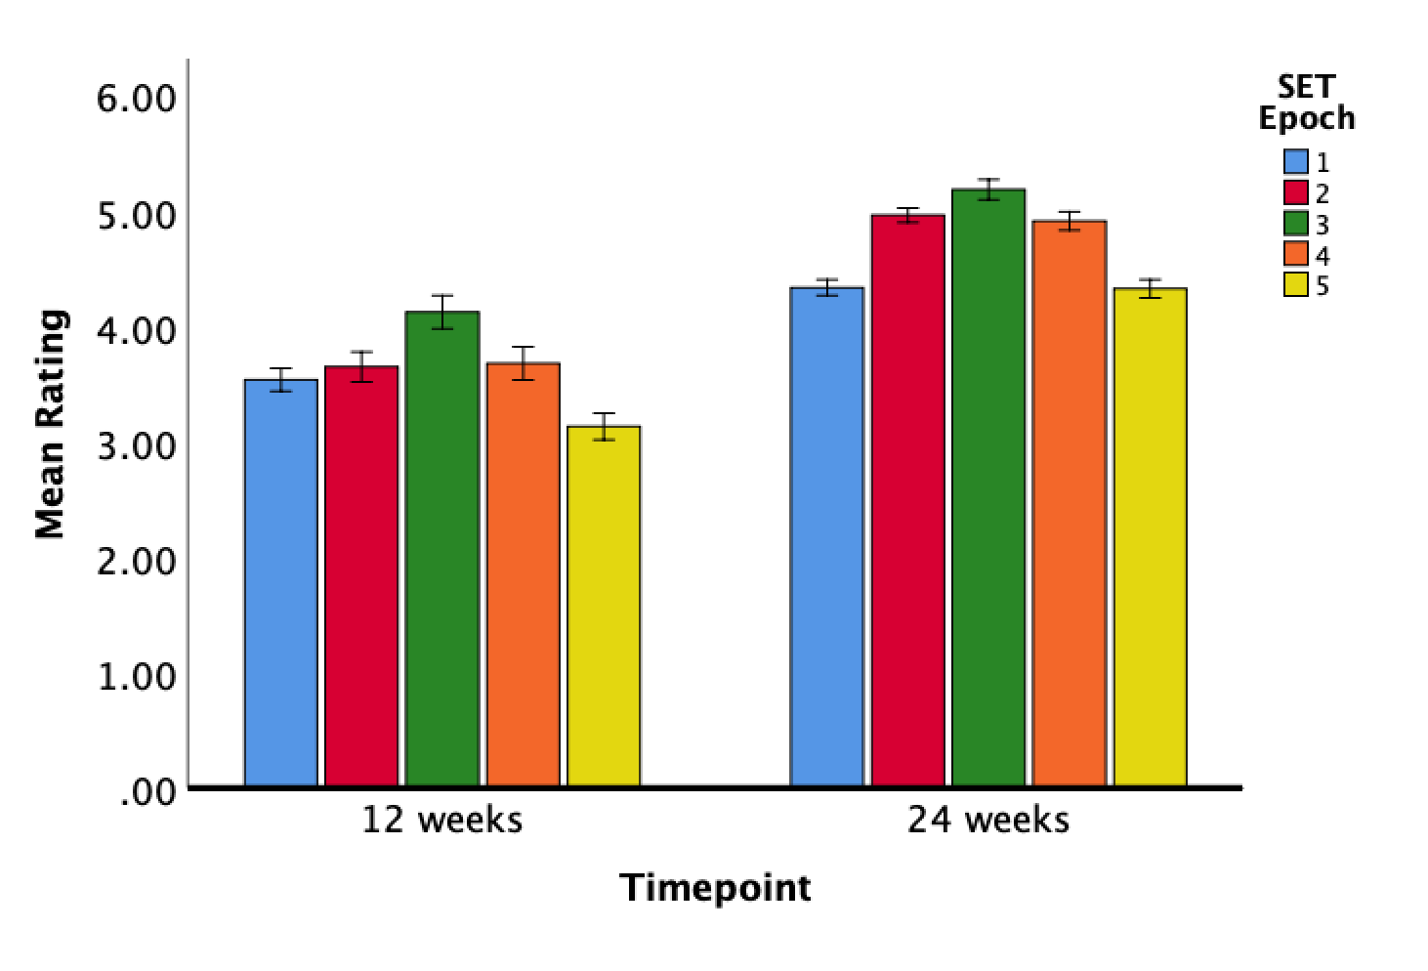Figure 2. Mean ratings on the secondary engagement scale across epochs at both 12 and 24 weeks. Error bars depict +/- 1 standard error of the mean.